This document assumes a basic understanding of Blender- all commands are in **bold.** It may be helpful to toggle between **wireframe** and **solid** view (in the upper right-hand corner of the 3D viewport). Open the file **instructions_scale-models_output-SA-V.blend** and follow instructions below. It may be easier to adapt the included mesh **serena_tapered** instead of creating a new mesh from scratch.

*Constructing a 3D marine mammal model in Blender*

1. Add dorsal and lateral images. | **Add > Image > Reference > (**select images from directory)
   1. These should be from the same individual whale.
   2. Rotate the images such that they are perpendicular to each other respective to the long axis of the whale.

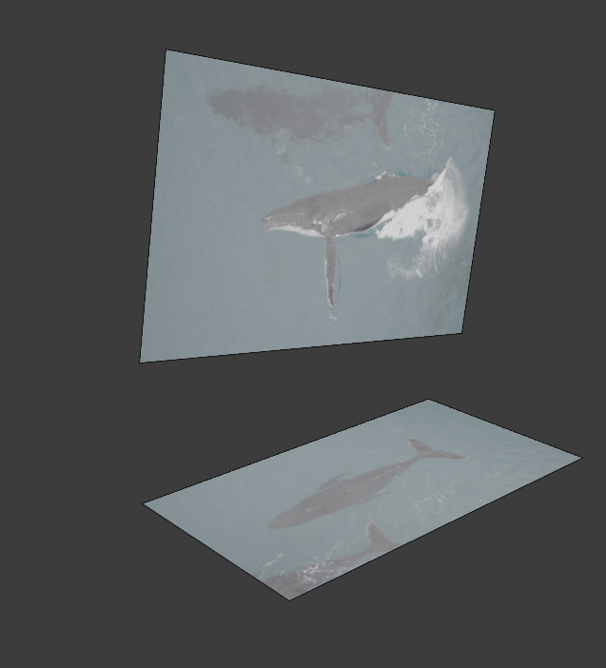

1. **Scale** the images such that the total length for both dorsal and lateral images is the same visually.
   1. i.e., the rostrums and fluke notches on BOTH images will have the same coordinates if the dorsal and lateral images are aligned.

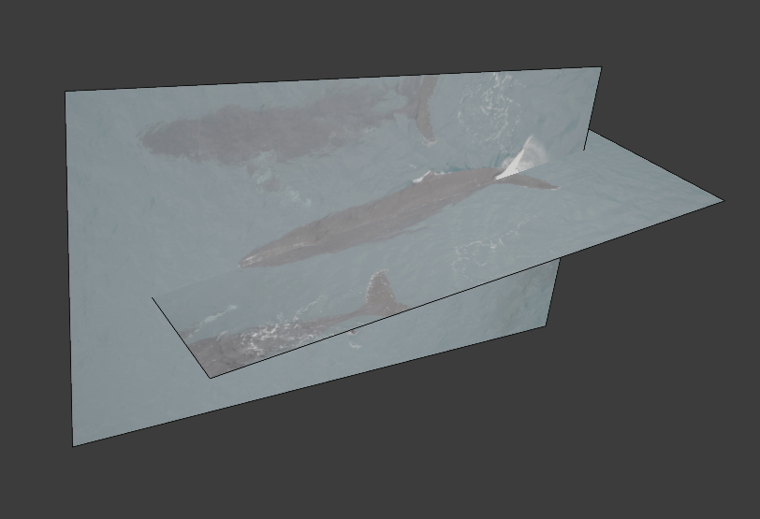

1. Add a cylinder to the 3D viewport. | **Add > Mesh > Cylinder**
   1. Subdivide it into 1% intervals such that it consists of 101 ellipses, where the 1st ellipse is at the rostrum of the whale, and the 101st ellipse is at the fluke notch of the tail. | **Edit mode > CTRL + R >** scroll wheel up a few; ellipses will appear **>** double click **>** in the ‘loop cut and slide’ dialogue box, change number of cuts to 99 > **Enter**
   2. Dissolve ellipses 87-100 individually so there is one ellipse at 85% body length and one at 100% body length. | **ALT +** click ellipse > right click **> dissolve edges**
   3. Merge all vertices in the 1st ellipse (the rostrum) at center; they will collapse into a point. | **ALT + click ellipse > mesh > merge > at center**
   4. Repeat for the 101st ellipse (the fluke notch). | **ALT + click ellipse > mesh > merge > at center**

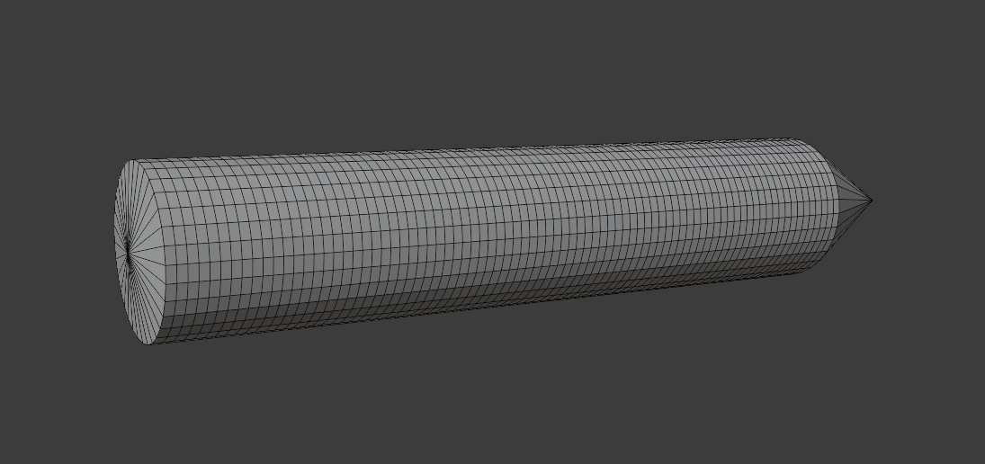

1. **Scale** and overlay the mesh (former cylinder) such that the designated rostrum and fluke notch align with the rostrum and fluke notch, respectively, of the two images.

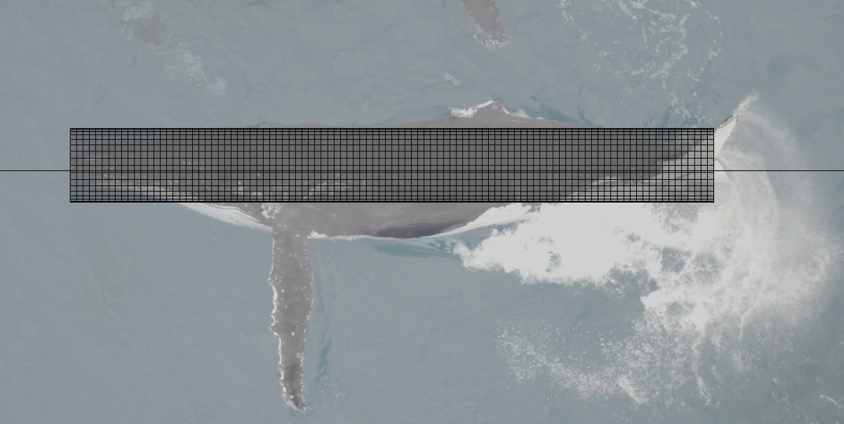

1. In dorsal view, adjust the widths of ellipses (one axis only; **scale + x**) to match the width of the whale at the corresponding point
   1. If the whale is not in a perfectly straight line, the picture will need to be moved or rotated (click image, **R)** slightly to preserve symmetry
   2. It may be helpful to scale every 5th ellipse, and then return at the end to scale the ellipses in between

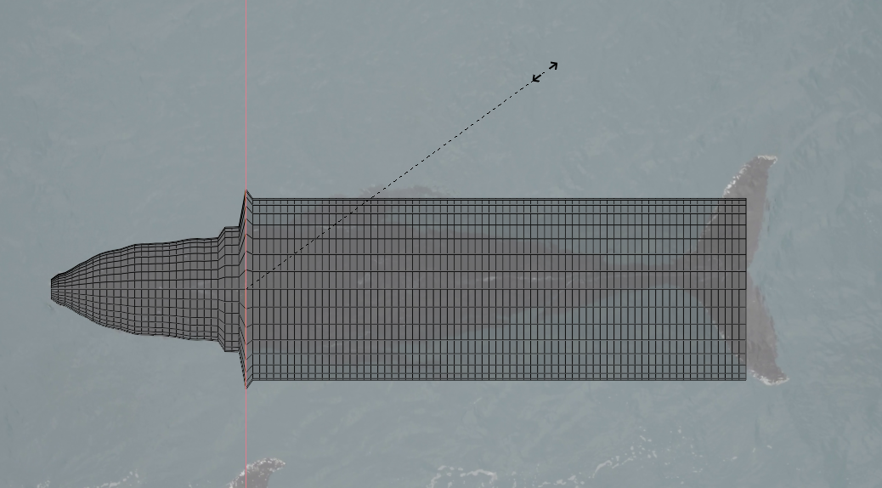

1. Repeat above step until end of body core is reached.
2. In **lateral** view, adjust the heights of ellipses (one axis only; **scale + z**) to match the height of the whale at the corresponding point.
   1. If the whale is not in a perfectly straight line, the picture will need to be shifted/rotated slightly to preserve symmetry.
   2. It may be helpful to scale every 5th ellipse, and then return at the end to scale the ellipses in between.
3. If the model is very “bumpy” after all ellipses are sized correctly, it may help to smooth vertices in the width and height dimensions to make it more realistic. | **Tab** to enter edit mode > **Vertex > Smooth vertices >** uncheck Y-axis so the length is not changed > **Repeat *n*** times until satisfied with the result (see below for a rough example).

Before smoothing.

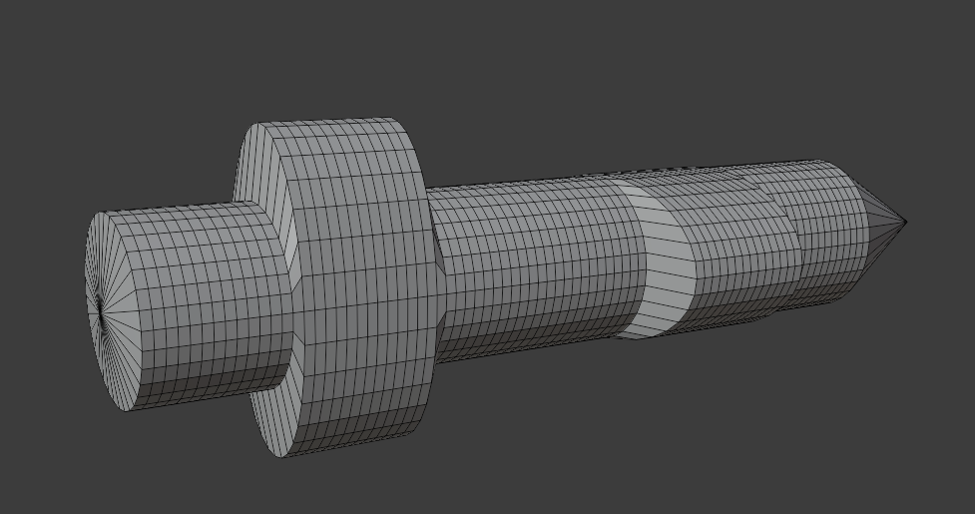

After smoothing. Note the Y axis box is unchecked in the lower left.

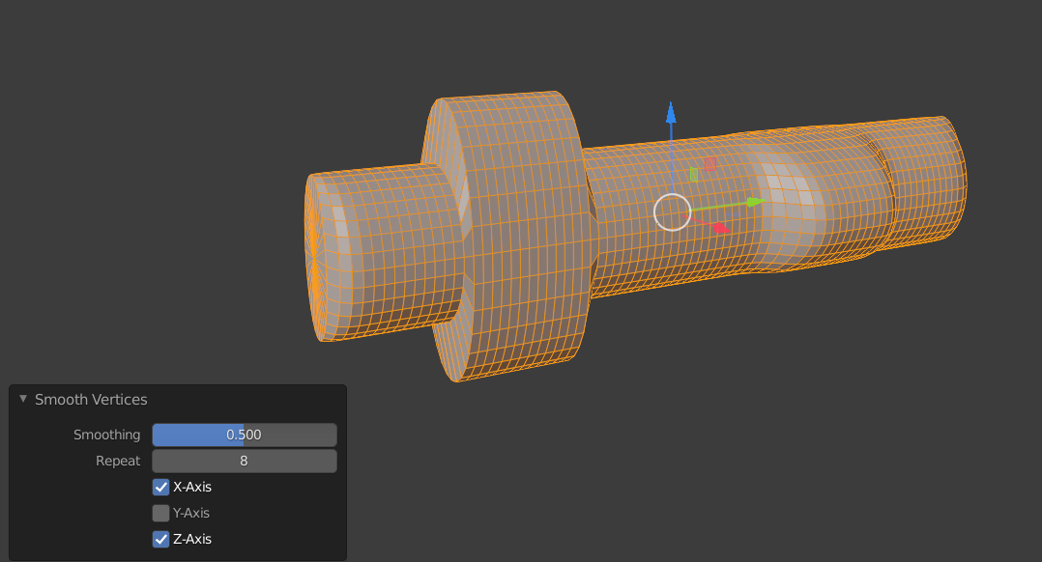

Final scaled model from orthogonal, dorsal, and lateral views.

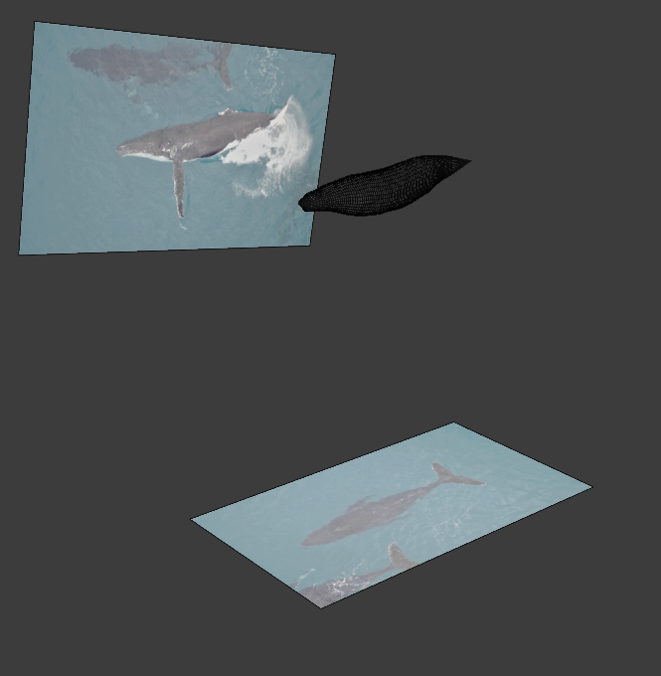

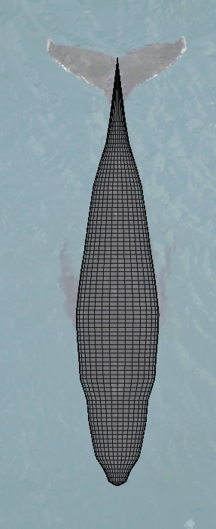

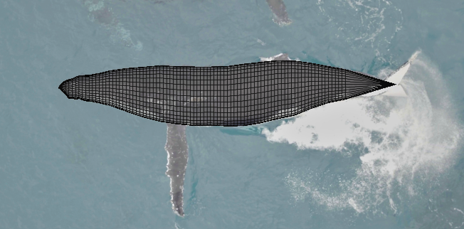

Additional steps below.

Because of the way the scaling code is written, the “order” of the vertices and edges are extremely important. For example, the vertex representing the rostrum MUST be the first vertex (indexed to zero) and the fluke notch MUST be the final vertex (indexed to 2721 if the model is constructed as described above).

1. Enable **view indices** – follow [this link](https://blender.stackexchange.com/questions/3249/show-mesh-vertices-id) for a simple guide.
2. Click **numpad 3** to orient the view laterally > **Tab** to enter edit mode, if not already > press **1** to enter vertex mode > press **A** to select all vertices > **mesh** > **sort elements > view X axis**
3. press **2** to enter edge mode > press **A** to select all edges > **mesh** > **sort elements > view X axis**

The indices for the rostrum and fluke notch must be the first and last in the entire mesh, respectively.

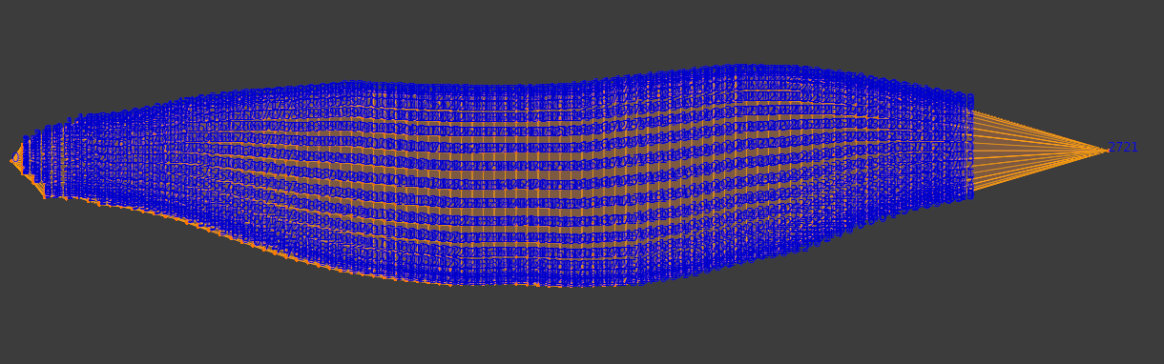

1. Once the model is constructed, open a new window and create 3 panes: one for each component under the Scripting tab in the Editor Type window (upper left). You will see a script labeled ‘calc_vols_and_SA’ which will generate volume and surface area estimates for each 5% interval.
2. Open the README.docx to continue.